**The Zoom Meeting look**

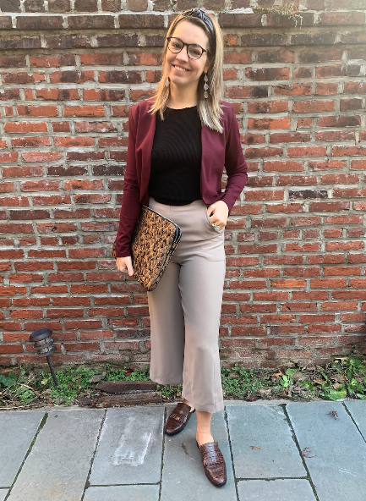

[shop the blazer](https://www.shop-kin.com/products/ripley-radar-elderberry-blazer?_pos=1&_psq=rip&_ss=e&_v=1.0)

[shop the top](https://www.shop-kin.com/products/bailey-44-ondine-sweater-top?_pos=4&_psq=baile&_ss=e&_v=1.0)

[shop the pants](https://www.shop-kin.com/products/bailey-44-sabrina-pant?_pos=2&_psq=baile&_ss=e&_v=1.0)

[shop the loafers](https://www.shop-kin.com/products/senso-seb-loafer-cocoa?_pos=1&_psq=senso%20lo&_ss=e&_v=1.0)

[shop the computer sleeve](https://www.shop-kin.com/products/hvisk-13-computer-sleeve-leopard-silver-multi?_pos=4&_psq=computer%20sle&_ss=e&_v=1.0)

[shop the headband](https://www.shop-kin.com/products/nuance-vegan-leather-headbands?_pos=2&_psq=headban&_ss=e&_v=1.0)

[shop the earrings](https://www.nuance-jewelry.com/products/tiered-geode-drops?_pos=1&_sid=6e4fa8ab3&_ss=r)

[shop the ring](https://www.nuance-jewelry.com/products/druzy-rings?_pos=1&_sid=b006f7c84&_ss=r)

**Home for the Holidays Look**

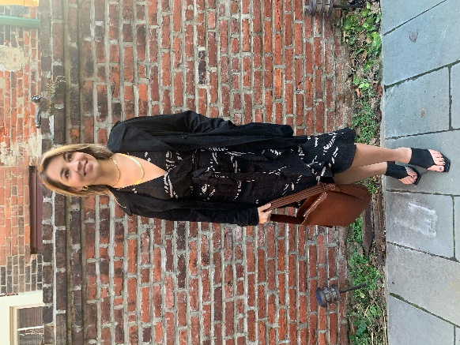

[shop the dress](https://www.shop-kin.com/collections/dresses/products/copy-of-cupcakes-and-cashmere-teyana-jacket-1)

[shop the jacket](https://www.shop-kin.com/collections/jackets-outerwear/products/bailey-44-sydney-jacket)

[shop the shoes](https://www.shop-kin.com/products/senso-ninah-ii?_pos=1&_sid=f95791eb8&_ss=r)

[shop the bag](https://www.shop-kin.com/products/hvisk-eliv-bag?_pos=1&_sid=7b2c5bb9c&_ss=r)

[shop the earrings](https://www.shop-kin.com/products/nuance-callie-hoops-small?_pos=1&_sid=f3aed9acf&_ss=r)

[shop the necklaces](https://www.shop-kin.com/products/nuance-river-chain-1?_pos=1&_sid=245e90d3e&_ss=r)

**Weekender Look**

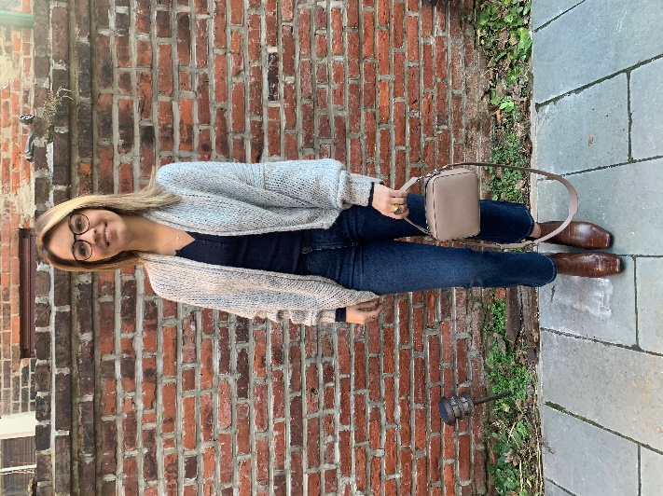

[shop the sweater](https://www.shop-kin.com/products/john-and-jenn-earnest-cardigan)

[shop the henley shirt](https://www.shop-kin.com/products/margaret-oleary-heirloom-henley-navy?_pos=1&_psq=henley&_ss=e&_v=1.0)

[shop the jeans](https://www.shop-kin.com/products/dl1961-bridget-boot-high-rise-instasculpt-crop-glendale?_pos=1&_psq=bridget&_ss=e&_v=1.0)

[shop the shoes](https://www.shop-kin.com/products/senso-genevieve-iv?_pos=3&_sid=a09e822d3&_ss=r)

[shop the bag](https://www.shop-kin.com/products/hvisk-glaze-bag?_pos=5&_sid=0db6c0c99&_ss=r)

[shop the necklace](https://www.shop-kin.com/products/nuance-crystal-eye-earring)

[shop the earrings](https://www.nuance-jewelry.com/products/icon-studs?_pos=1&_sid=3fa969516&_ss=r)